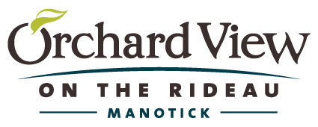
NOVEMBER EVENTS
Join us for ‘Coffee & Conversation’ on Women’s Day
With Special Guest and 1310 News radio personality

Carol Anne Meehan
OPEN HOUSE All Day!

Saturday, November 4th
Beginning at 10:00 am

Bring your friends, sisters, mothers and daughters to
Celebrate Women’s Day!
Fill out a ballot to win fabulous Gift Certificates from Local Merchants.
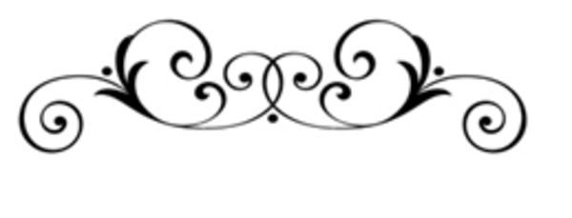

Nygard Fashion Show

Spruce up your Fall wardrobe with Ladies Fashions from NYGARD

Wednesday, November 22nd
2:00 pm – 4:00 pm

Clothing will be available for purchase
Door Prizes, light refreshments, and much more!

Please RSVP at 613-692-2121
1145 Bridge St. Manotick, ON

